

**CE 200-Summer Practice I**

**CE 300-Summer Practice I I**

“Field Internship Report: Gebze–Orhangazi–İzmir Motorway and İzmit Bay Crossing Project”

**Full Name:**

**Student Number:**

**Department:**

**University:** Çankaya University

**Academic Year / Term:** (e.g., 2024–2025 Summer Term)

**Company / Institution Name:**

**Internship Location:** (e.g., Altınova, Yalova – Turkey)

**Internship Dates:** (e.g., 25.08.2014 – 20.09.2014)

**Report Submission Date:** (e.g., 19.09.2014)

**Supervisor’s Name and Title *(To be filled by the department)*:**

# TABLE OF CONTENTS

## Introduction p.1

**Preface…………………………………………………………………………. p.6** **Internship Activities and Related Methodology ………………….…………………p.7**

**Global Impact of Engineering Practices ……….………………….…………………p.7 Ethical Behavior and Professional Responsibility……………….…………………...p.7**

**Conclusion……………………………………………………………………..p.38 References……………………………………………………………………...p.39 Appendix A -** **Daily Reports.………………………………………………….p.40**

**Appendix B -** **Interview with the Supervisor.……………………………….. p.40**

**Appendix C -** **Statement of Non-Plagiarism.……………………………….... p.40**

**Appendix D - Internship Report Evaluation Form.……………………….... p.40**

# INTRODUCTION

**(2-4 pages)**

***For this section consider the following:***

1. *The report demonstrates a clear understanding of the internship's objectives.*

The construction project which is called Gebze–Orhangazi-İzmir (Including İzmit Bay Crossing Suspension Bridge and Access Roads) Motorway is the project I did my summer practice. The main purpose of the project is linking the two major cities of the Turkey called İzmir and İstanbul. When the alternatives of the transportation are compared, instead of passing the İzmit Bay by an automobile in 80 minutes or using ferries taking time between 45 or 60 minutes, İzmit Bay Suspension Bridge will be more economical since passing İzmit Bay will just take 6 minutes. When the project is done, İstanbul-İzmir motorway will be shorter by about 140 km.

**Name of the Work:** Gebze–Orhangazi-İzmir (Including İzmit Bay Crossing Suspension Bridge and Access Roads) Motorway Build-Operate-Transfer Project

**Owner:** General Directorate of Highways- KGM

**Contractor:** OTOYOL / Nömayg Joint Venture

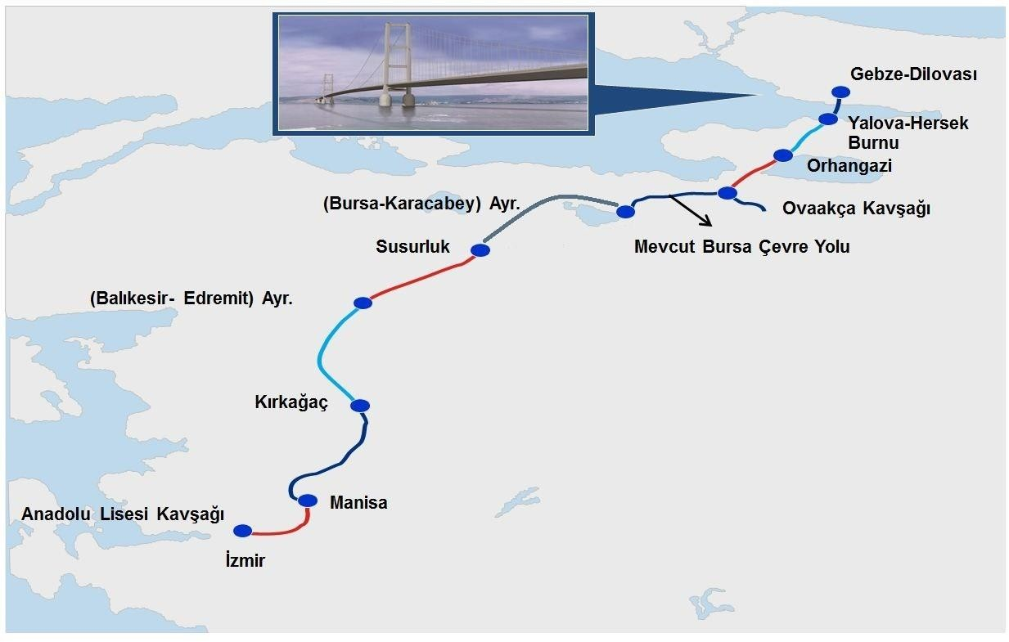

## Figure 1. The map shows the route of project

## PREFACE

## (1-2 pages)

***For this section consider the following:***

1. *The report includes relevant information about the company/organization and the tasks performed by the student.*

**Name of Organization:** OTOYOL Inc. Co

**Contact Adress:** Bilkent Plaza A3 Blok No:21-24 06800, Bilkent/ANKARA

**Site Location (Center Worksite):** Yalova İzmit Yolu Cad. Devletaltı Yolu Tersaneler Bölgesi Çavuşçiftliği Mevkii, Altınova – YALOVA – TÜRKİYE

**Brief History:** The tender of Gebze-Orhangazi-İzmir (Including İzmit Bay Crossing Suspension Bridge and Access Roads) Motorway Build-Operate-Transfer Project was held 9 April 2009 and the tender was gotten by Nurol-Özaltın-Makyol-Astaldi-Yüksel-Göçay Joint Venture. OTOYOL Inc. Co was established by Nurol-Özaltın-Makyol-Astaldi-Yüksel-Göçay Joint Venture’s partners in September 20, 2010 so that the company undertakes the works related to the Gebze-Orhangazi-İzmir (Including İzmit Bay Crossing Suspension Bridge and Access Roads) Motorway Build-Operate-Transfer Project. Otoyol Inc. Co will both construct and operate the motorway for 22 years and 4 months.

**Organization Chart:**

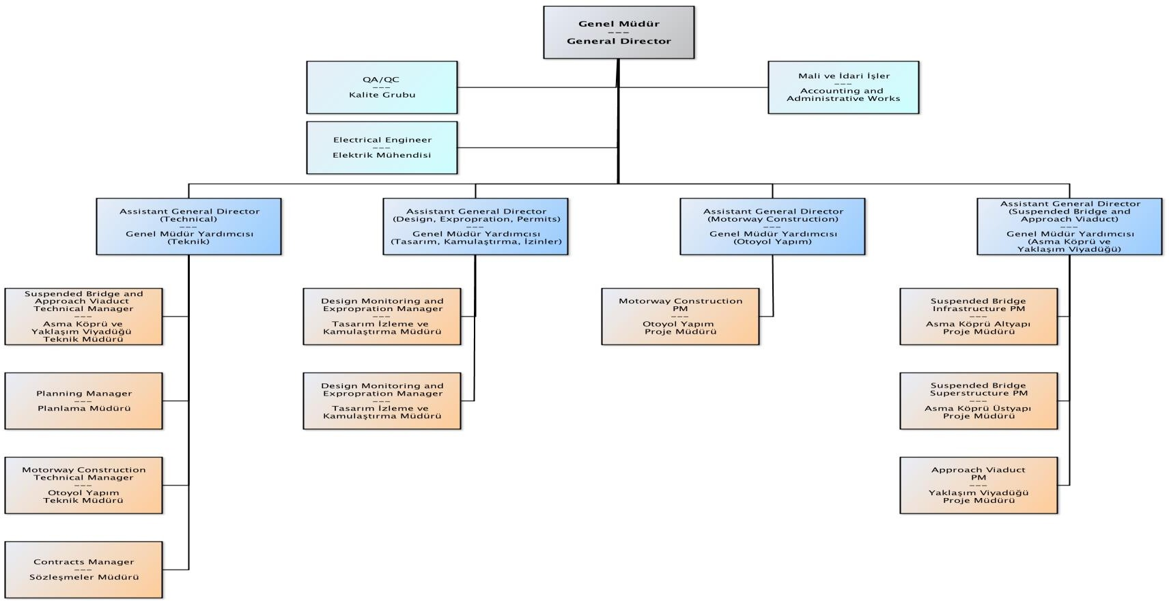

**Figure 4.** Organization Chart

# INTERNSHIP ACTIVITIES AND RELATED METHODOLOGY

(12–20 pages)

***For this section consider the following:***

1. *The report relates the intern's academic knowledge to their practical experiences.*
2. *The student effectively identifies, and addresses challenges encountered during the internship.*
3. *The solutions to problems faced in the work are adequately discussed, if any.*
4. *In-text references or citations are used.*

**Week 1** (3–5 pages)

**Week 2** (3–5 pages)

**Week 3** (3–5 pages)

**Week 4** (3–5 pages)

**Global Impact of Engineering Practices**

**(1-4 pages)**

In this section, reflect on how your internship experience demonstrated the broader effects of engineering on society and the environment. You are expected to:

* Identify how the project contributes to societal needs such as transportation, infrastructure, or public safety.
* Discuss any observed efforts toward sustainability (e.g., recycling materials, minimizing environmental impact, energy efficiency).
* Relate your experience to one or more of the **UN Sustainable Development Goals (SDGs)** such as: (<https://sdgs.un.org/goals>)
  + SDG 9: Industry, Innovation and Infrastructure
  + SDG 11: Sustainable Cities and Communities
  + SDG 13: Climate Action
* Mention any practices related to health and safety, resource management, or social responsibility that you encountered.
* Provide specific examples from your internship where these global concerns were considered or addressed.

## ****Ethical Behavior and Professional Responsibility****

**(1-4 pages)**

This section should describe your understanding and observations regarding ethical conduct during the internship. You are expected to:

* Describe how ethical principles were applied in your workplace (e.g., honesty in reporting, safety compliance, fairness in task distribution).
* Reflect on how engineers are expected to behave professionally and responsibly.
* Explain any codes of conduct, safety rules, or legal regulations that were followed.
* Include how you personally behaved or contributed in a way that aligns with professional and ethical standards.
* If applicable, discuss any challenges you observed regarding ethical decision-making or workplace behavior.

Figures and Tables

Example Figure

Figures should appear at the correct position in the text with the Figure caption below the figure.

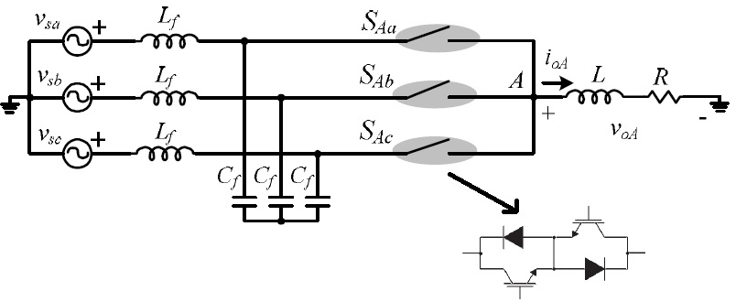

**Figure 1.** Example Figure

Example Table

Tables should appear at the correct position in the text with the Table caption above the table.

Table 1. Example Table

|  |  |  |  |  |
| --- | --- | --- | --- | --- |
|  | **Column1** | **Column2** | **Column3** | **Column4** |
| Values | 1 | 2 | 3 | 4 |
| Values | 1 | 2 | 3 | 4 |
| Values | 1 | 2 | 3 | 4 |
| Values | 1 | 2 | 3 | 4 |

# CONCLUSION

# (2-4 pages)

In this section, you should reflect on your overall internship experience. The conclusion is not just a summary of your tasks, but an opportunity to express what you learned, how you developed professionally, and how the internship contributed to your engineering education.

**Please consider the following points:**

1. **Summarize your internship experience:**
   * Where did you work?
   * What type of project were you involved in?
   * What were your primary tasks and responsibilities?
2. **Reflect on your technical learning:**
   * What new knowledge or skills did you gain related to engineering practice?
   * Which construction methods, materials, tests, or software did you become familiar with?
3. **Link to your academic courses:**
   * Which university courses helped you understand the work you were doing?
   * Give specific examples (e.g., *Soil Mechanics*, *Construction Materials*, *Project Management*).
   * Mention how your classroom knowledge was applied or strengthened during the internship.
4. **Professional and personal development:**
   * What did you learn about teamwork, communication, safety, and workplace ethics?
   * Did the internship help you improve time management or decision-making skills?
5. **Challenges and problem-solving:**
   * Describe any difficulties you encountered.
   * How did you handle or overcome them?
6. **Future perspective:**
   * How has this experience influenced your career plans?
   * What skills or knowledge do you want to improve in future internships or jobs?

**References**

Please ensure that every reference cited in the text is also present in the reference list. References should be numbered in the order of their appearance in the text. If more than one reference is to be cited, then a comma can be used, i.e., [1,2]. Besides, a dash can be used to show all references, i.e., [1-4].

**Citation in list**

***Reference to a journal publication (one author)***

[1] N. T. Kirkland, “Magnesium Biomaterials – Past, Present and Future,” *Journal of Chemical Information and Modeling*, vol. 53, no. 9, pp. 1689–1699, 2013.

***Reference to a journal publication (two authors)***

[2] X.-N. Gu and Y.-F. Zheng, “A review on magnesium alloys as biodegradable materials,” *Frontiers of Materials Science in China*, vol. 4, no. 2, pp. 111–115, 2010.

***Reference to a journal publication (more than two authors)***

[3] T. Kizuki, H. Takadama, T. Matsushita, T. Nakamura, and T. Kokubo, “Preparation of bioactive Ti metal surface enriched with calcium ions by chemical treatment.,” *Acta Biomaterialia*, vol. 6, no. 7, pp. 2836–42, 2010.

***Reference to a book***

[4] B. Klaus and P. Horn, Robot Vision. Cambridge, MA, USA: MIT Press, 1986.

[5] D. C. Dunand, “Processing of Titanium Foams,” *Advanced Engineering Materials*, pp. 369–376, 2004.

***Reference to a chapter in an edited book***

[6] T. Ram Prabhu, S. Vedantam, and V. Singh, “Magnesium Alloys,” *Aerospace Materials and Material Technologies*, N. Eswara Prasad and R. J. H. Wanhill, Eds., pp. 3–27, 2017.

***Conference paper***

[7] M. Balog, M. Snajdar, P. Krizik, Z. Schauperl, Z. Stanec, and A. Catic, “Titanium-Magnesium composite for dental implants (BIACOM),” presented at *TMS 2017 146th Annual Meeting & amp; Exhibition Supplemental Proceedings*, California, USA, 2017.

***Thesis***

[8] P. Gunde, “Biodegradable magnesium alloys for osteosynthesis - Alloy development and surface modifications,” Ph.D. dissertation, E.T.H., Zurich, no. 19171, 2010.

***Webpage***

[9] J. Doe. “Press release: The Nobel Prize in Physics 2020"

nobelprize.org.https://www.nobelprize.org/prizes/physics/2020/press-release/ (accessed 07.09.2020).

# APPENDIX A – DAILY REPORT

## *The appendix covers brief information about the daily work.*

|  |  |  |  |
| --- | --- | --- | --- |
| **Day** | **Date** | **Description** | **Signature \*** |
| **1** | **25.08.2014** | * **Şantiye stajının ilk gününde işe giriş işlemlerinin yapılması için sigorta belgesinin teslimi yapıldı.** * **Proje Müdürü Fatih Zeybek ile tanışıldı kendisi şantiyede çalışabilmek için her çalışanın iş güvenliği eğitimden geçmesi gerektiği bilgisini verdi.** * **İş sağlığı ve güvenliği süpervizörü tarafından şantiyede uyulması gereken kurallar ve aldıkları güvenlik önlemleriyle birlikte iş kazalarının yaşanmamasını sağlamaya**   **çalıştıklarını belirtti.**   * **Şantiyede olabilecek kazalar ve yaşanmış olan kazalara dahil bilgiler de sunuldu.** * **İş sağlığı ve güvenliği kanununa göre çalışan ve işverenlerin hakları hakkında bilgiler verildi.** * **Eğitimin ardından iş sağlığı ve güvenliği hakkında bir sınav yapıldı.** * **Şantiyede kullanılacak olacak koruyucu ekipmanlar baret, yelek, iş ayakkabısı ve emniyet kemeri teslim alındı.** |  |
| **2** | **26.08.2014** |  |  |
| **3** | **27.08.2014** |  |  |
| **4** | **28.08.2014** |  |  |
| **5** | **29.08.2014** |  |  |
| **6** | **01.09.2014** |  |  |
| **7** | **02.09.2014** |  |  |
| **8** | **03.09.2014** |  |  |
| **9** | **04.09.2014** |  |  |
| **10** | **05.09.2014** |  |  |
| **11** | **08.09.2014** |  |  |
| **12** | **09.09.2014** |  |  |
| **13** | **10.09.2014** |  |  |
| **14** | **11.09.2014** |  |  |
| **15** | **12.09.2014** |  |  |
| **16** | **15.09.2014** |  |  |
| **17** | **16.09.2014** |  |  |
| **18** | **17.09.2014** |  |  |
| **19** | **18.09.2014** |  |  |
| **20** | **19.09.2014** |  |  |

## * This part needs to be signed by the Site Chief, who should be a Civil Engineer.

## * Bu bölüm, inşaat mühendisi unvanına sahip olan Şantiye Şefi tarafından imzalanmalıdır

**APPENDIX B – INTERVIEW WITH THE SUPERVISOR (Site)**

## (Must be filled in English)

## (Only for Site / Şantiye)

**Q1:** Please state your full name, academic background, and current position at the construction site.  
***(****Lütfen adınızı, akademik geçmişinizi ve şantiyedeki mevcut görevinizi belirtiniz.****)***

**Q2:** How long have you been working in this role, and what are your primary responsibilities on site?  
***(****Bu pozisyonda ne kadar süredir çalışıyorsunuz ve şantiyedeki temel sorumluluklarınız nelerdir?****)***

**Q3:** What are the main stages and challenges in the on-site execution of a large-scale construction project?  
***(****Büyük ölçekli bir inşaat projesinin şantiyede uygulanmasında başlıca aşamalar ve karşılaşılan zorluklar nelerdir?****)***

**Q4:** What is the importance of site supervision in ensuring project quality, safety, and timely delivery?  
***(****Proje kalitesinin, güvenliğinin ve zamanında tamamlanmasının sağlanmasında şantiye denetiminin önemi nedir?****)***

**Q5:** What technical and practical skills should a civil engineering student develop to perform effectively on a construction site?  
***(****Bir inşaat mühendisliği öğrencisi şantiyede etkili çalışabilmek için hangi teknik ve pratik becerileri geliştirmelidir?****)***

**Q6:** What advice would you give to civil engineering students to help them maximize their learning during a site internship?  
***(****Şantiye stajı sırasında öğrencilerin öğrenme düzeylerini en üst düzeye çıkarabilmeleri için ne gibi tavsiyelerde bulunursunuz?****)***

**APPENDIX B – INTERVIEW WITH THE SUPERVISOR (Office)**

## (Must be filled in English)

## (Only for Office / Ofis)

**Q1:** Please state your full name, academic background, and current position in the company.  
***(****Lütfen adınızı, akademik geçmişinizi ve firmadaki mevcut görevinizi belirtiniz.****)***

**Q2:** How long have you been working in this role, and what are your main duties within the technical office?  
***(****Bu görevde ne kadar süredir çalışıyorsunuz ve teknik ofisteki başlıca sorumluluklarınız nelerdir?****)***

**Q3:** What are the key responsibilities of a technical office in a construction company, and how does it support site operations?  
***(****Bir inşaat firmasındaki teknik ofisin temel görevleri nelerdir ve şantiye faaliyetlerine nasıl katkı sağlar?****)***

**Q4:** What types of documents, analyses, or software tools are typically used in your daily work?  
***(****Günlük çalışmalarınızda genellikle hangi dokümanlar, analiz yöntemleri veya yazılımlar kullanılmaktadır?****)***

**Q5:** What qualifications, digital skills, and engineering knowledge should a civil engineering student possess for success in a technical office?  
***(****Bir inşaat mühendisliği öğrencisi teknik ofiste başarılı olabilmek için hangi niteliklere, dijital becerilere ve mühendislik bilgisine sahip olmalıdır?****)***

**Q6:** What suggestions would you offer to interns to gain meaningful insights from their office-based experience?  
***(****Ofis ortamında yapılan bir stajdan öğrencilerin en verimli şekilde faydalanabilmesi için ne gibi önerilerde bulunursunuz?****)***

## APPENDIX C - STATEMENT OF NON-PLAGIARISM

I hereby declare that all information in this report has been obtained and presented in accordance with academic rules and ethical conduct. As required by these rules and conduct, I also declare that I have fully cited and referenced all materials and results that are not original in this work.

Date: __/__/____ Student’s Name and Surname

Signature

## APPENDIX D - INTERNSHIP REPORT EVALUATION FORM

## *(To be filled by the lecturer)*

**INTERNSHIP REPORT EVALUATION**

|  |  |  |
| --- | --- | --- |
| **Evaluation Criteria** | **Satisfactory** | **Unsatisfactory** |
| 1. Report format and language are clear and professional. | ☐ | ☐ |
| 2. Internship objectives and company background are well presented. | ☐ | ☐ |
| 3. Activities are described with technical detail and academic relevance. | ☐ | ☐ |
| 4. Challenges and solutions (if any) are explained. | ☐ | ☐ |
| 5. Methods, tools, or references are mentioned. | ☐ | ☐ |
| 6. Internship tasks are connected to relevant university courses. | ☐ | ☐ |
| 7. Ethical responsibility, safety, and teamwork are addressed. | ☐ | ☐ |
| 8. Global and societal impacts of engineering are discussed. | ☐ | ☐ |
| 9. Conclusion includes meaningful reflection and learning outcomes. | ☐ | ☐ |

**Additional Comments:**

..........................................................................................................................................................................................................................................................................................................................................

**Recommendation:**

☐ The student’s report is **satisfactory** and the internship is **successfully completed**.  
☐ The student’s report is **unsatisfactory** and must be revised. The revised report must be submitted by: [.... / .... / ....].